What Can We Measure at Harcourt P.S?
Item (Name and Draw) | Estimation (Metres/m) | Measurement (Metres/m) | Measuring Tool
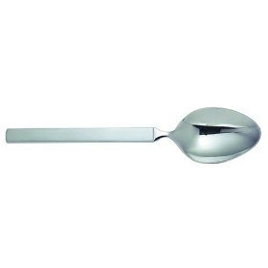  spoon | less than 1 metre | much less than 1 metre | string
 | less than a metre
 | less than a metre
 | about 1 metre
 | about 1 metre
 | more than a metre
 | more than a metre
Useful Words
less than a metre close to a metre almost a metre about a metre
much less than a metre and a little bit of a metre and more of a metre and almost another metre

