June 9th, 2009 Name:_______________________
How long, tall or wide is that?

- Circle the correct answer

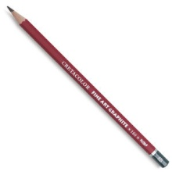
A pencil is: about a metre much less than a metre more than a metre

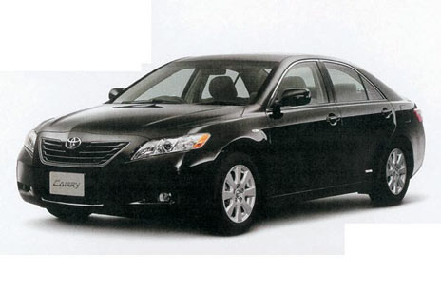
A car is: about a metre more than a metre less than a metre

A school table is: less than a metre about a metre a lot more than a metre

- Complete the table.
  - Make sure to estimate first
  - You can ask a parent to help you measure

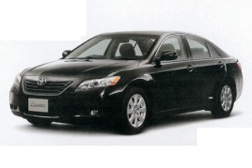  Object (name) | Estimate (metres) | Measurement (metres)
Car | 6 metres | Almost 5 metres
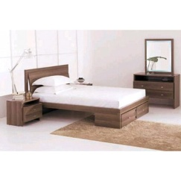
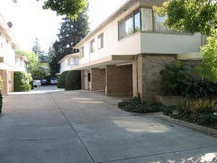
Bedroom wall

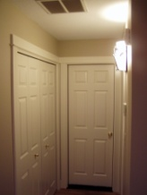
Door (how tall)

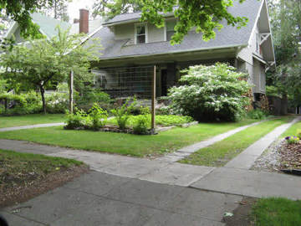
Front or back garden

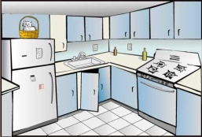

Kitchen

Useful Words
less than a metre close to a metre almost a metre about a metre
much less than a metre and a little bit of a metre and more of a metre and almost another metre

